## **Title of Project: Cricket Database Management**

**Group Members: 1. Mayur Kharmate (23104)**

**2. Aniket Uttekar (23207)**

**3. Kunal Desai (23204)**

**Front End Used: PHP**

**Database Used: MySQL**

**Abstract :**

**IPL Database Management is a cricket scheduling-based application exclusively for the game of cricket. The Application features schedules, information about teams, records of batting and bowling, creating new schedules, can search about players, it displays rank tables for teams and players. The admin has all authorities to make changes for the database so admin can add players, can add schedules, can add stadiums and also have permission to removing of them from the database. It features with searching of players involved in the game and retrieve the players of the particular match by selecting match number. Also, can fetch the schedules with their venue and squad available by the team, players selected for the current match. Admin can also authority to update the rating of the teams and also players runs and wickets and other match particulars in this database.**

**Introduction :**

**Cricket Database Management is a software application to  
manage all the activities concern to the cricket. This project will help  
the cricket organization to store all cricket related information. This  
application is useful store all the information related to the players,  
matches, grounds, etc., This project also provided with option to enter  
the match details ball by ball, so it automatically show the score  
board. which in turn can be connected to the score board.  
The main objective of the application is to automate the existing  
method of managing data manually to systematic storage of data,  
which can be searched any time as and when required. The other main objective of this application is to store all the player, match, ground details. The other main objective of this project is to show score board when the match is going on.  
This application can be used by any cricket organizations. So  
through out the country this program is very useful. Also this program  
helps the organizer to store data in digital form.The user’s login window also featured with create an account, player search for players information, getting future match particulars, rankings, schedules and their venues. Can fetch the schedules with their venue and squad available by the team, players selected for the current match.**

**ER Diagram:**

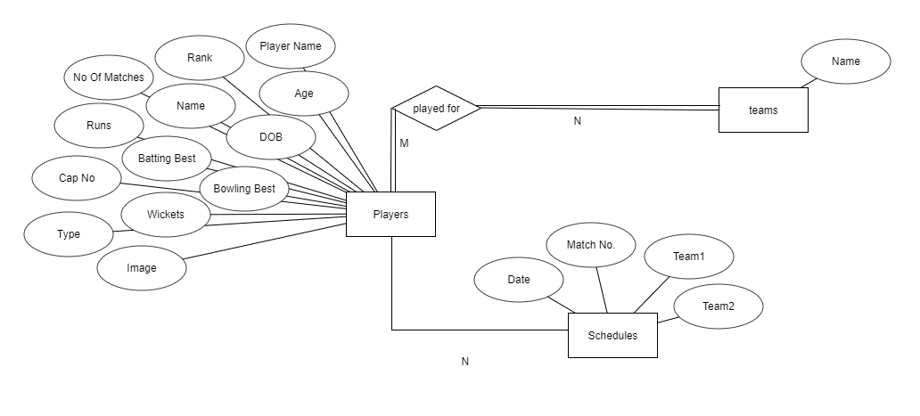

**Relational Model:**

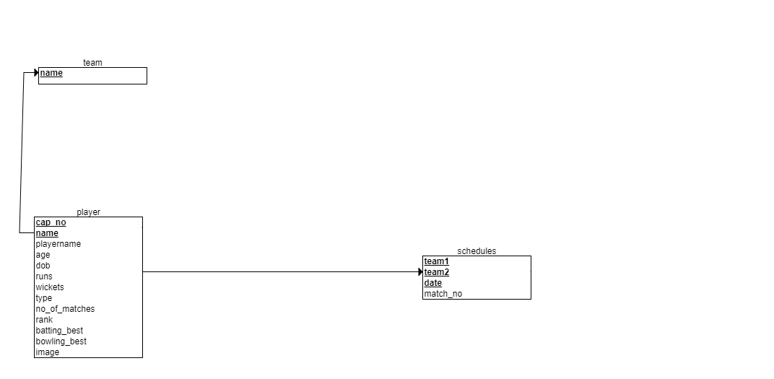

**Screenshots of Output & Testing Results:**

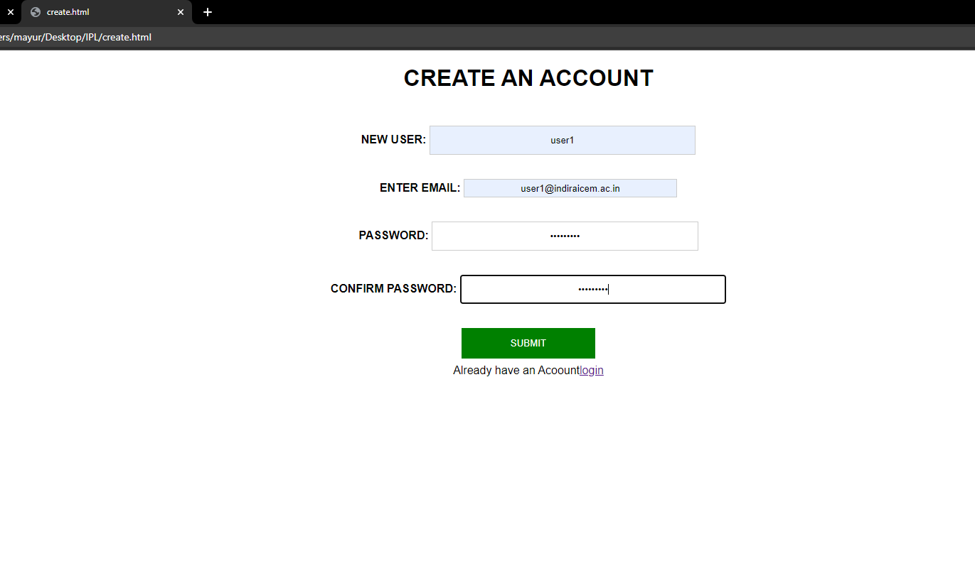

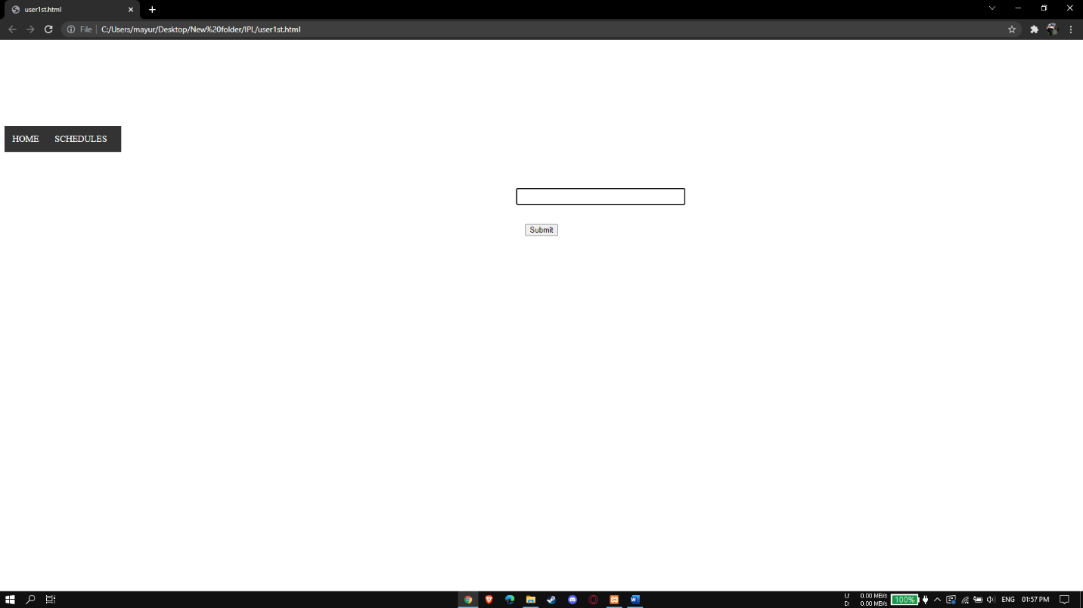

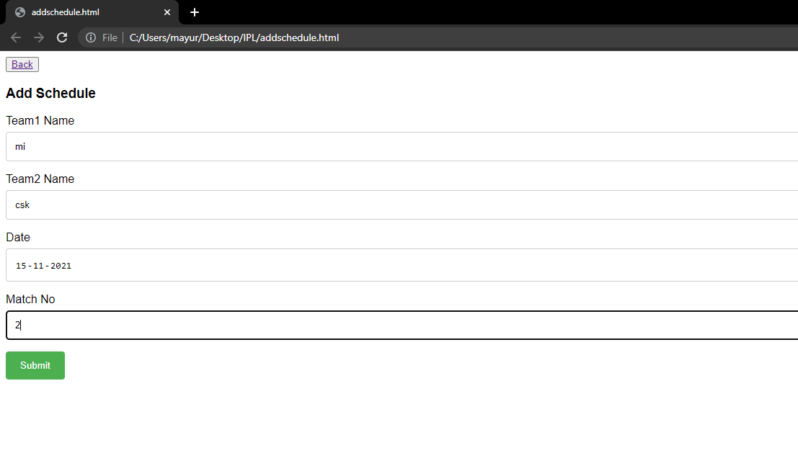

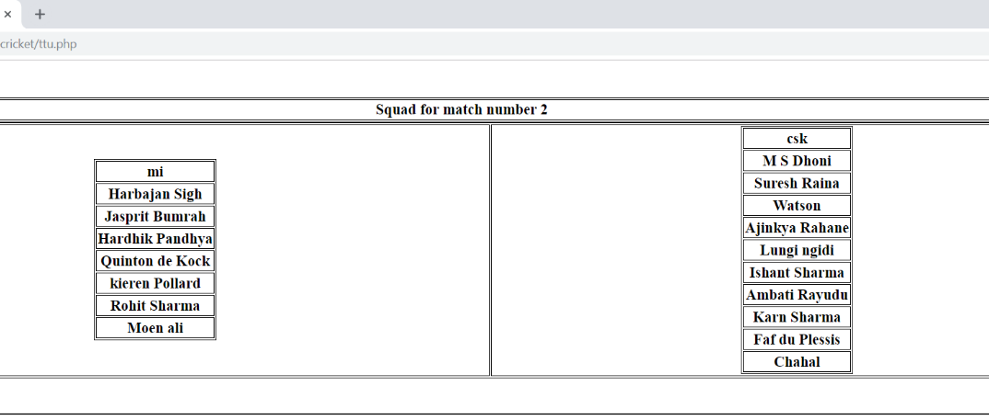

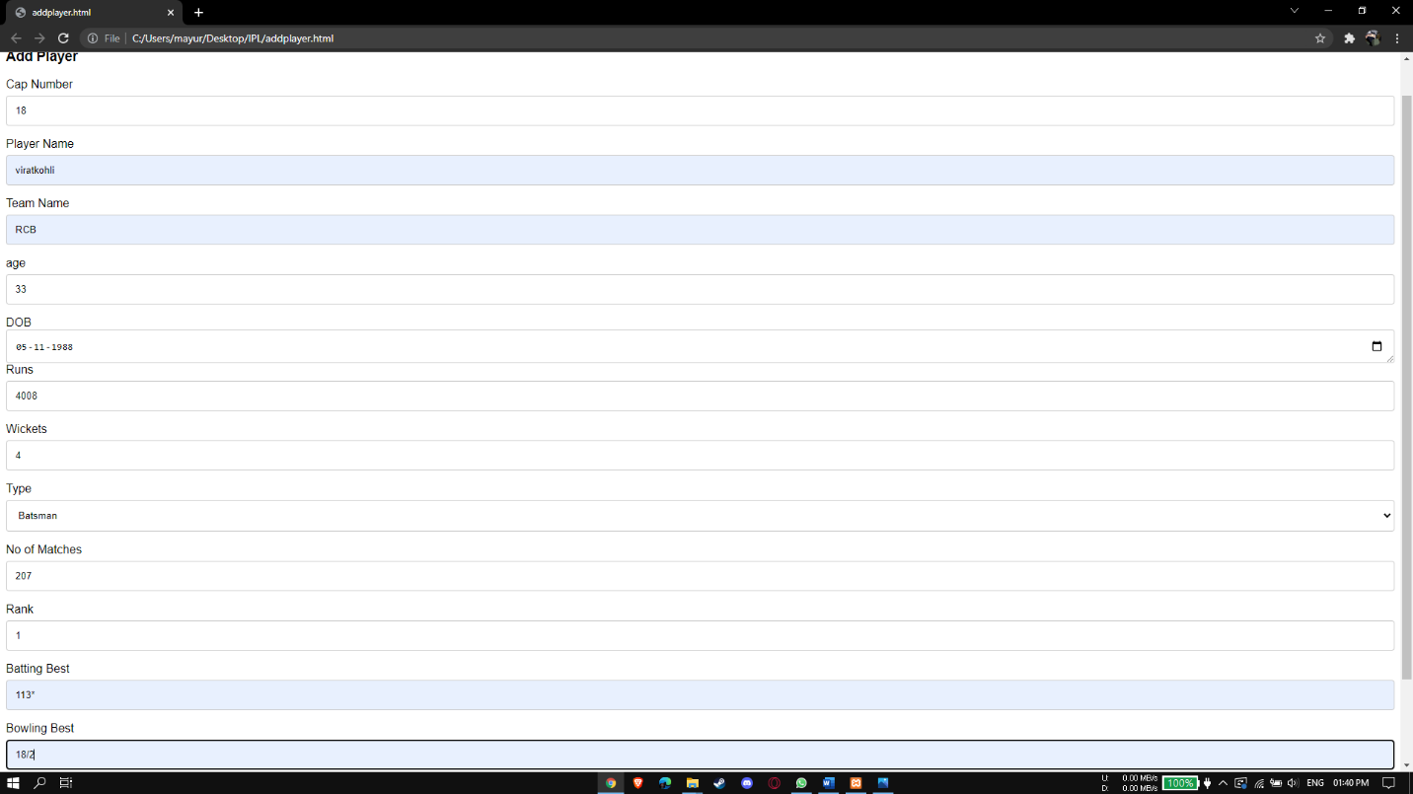

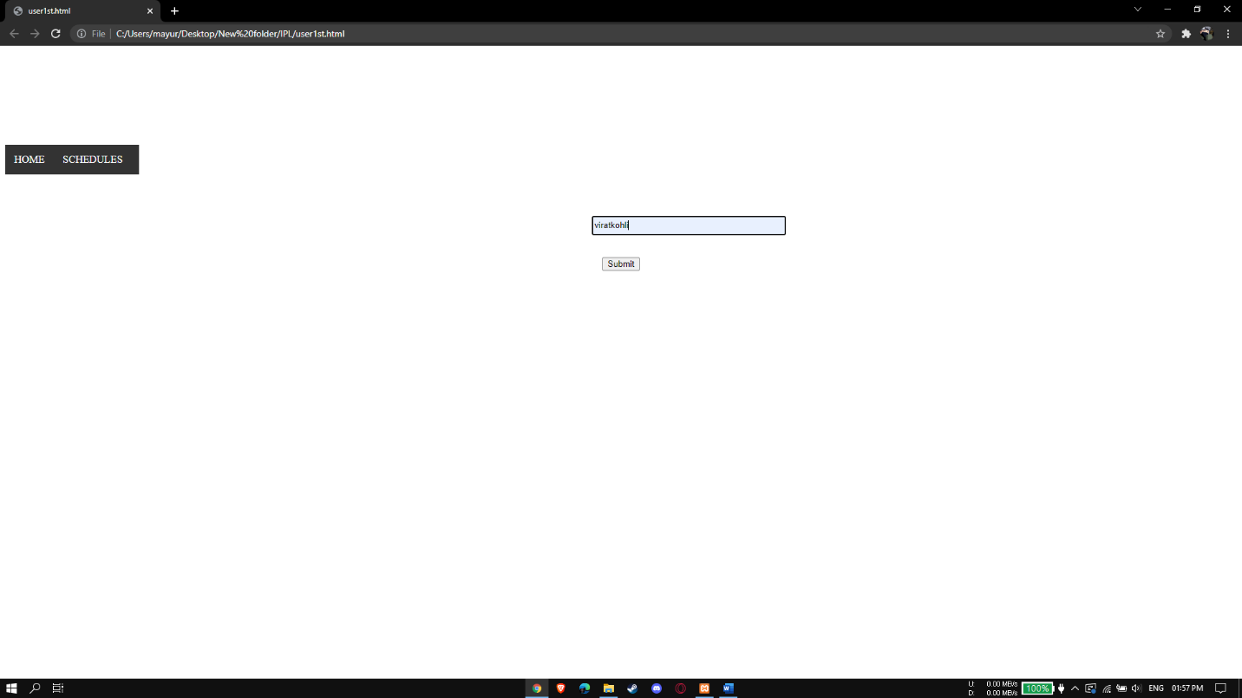

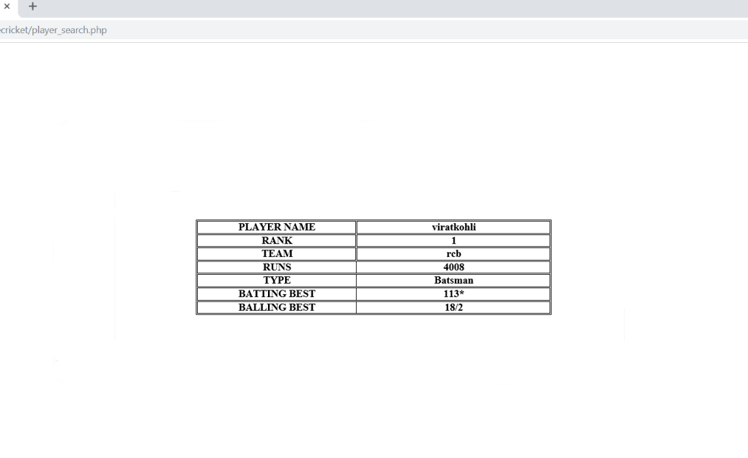

**Conclusion:**

**The project, developed using PHP and MySQL is based on the requirement specification of the user and the analysis of the existing system, with flexibility for future enhancement. The expanded functionality of today’s software requires an appropriate approach towards software development. This IPL database management software is designed for people who want to manage various particulars can be known by recording them in the database.**